C-DAC Mumbai Lab Assignment-2
C-DAC Mumbai
Name: Mohit Patil | Batch : Aug 2026
Course : Advance Computing | Date Of Submission: 23/08/2026

Problem 1: Grade Evaluation System

Problem Statement:
Write a Java program that calculates the average marks of a student and determines the grade based on the following criteria:
Grade A: Average marks ≥ 90
Grade B: Average marks between 70 and 89 Grade C: Average marks between 50 and 69 Grade D: Average marks between 30 and 49 Fail: Average marks < 30

Predefined Values (Try with different values as well):

- Marks in Maths = 80
- Marks in Science = 85
- Marks in History = 90

Expected Output:
Average Marks: 85 Grade: B

Code:
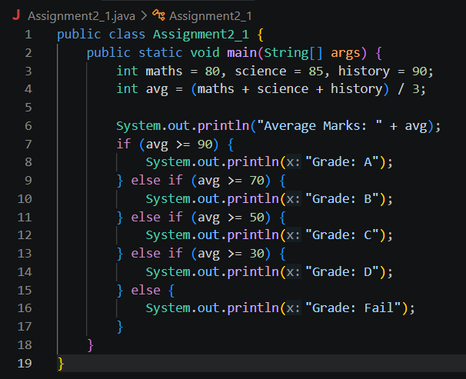

Problem 2: Leap Year

Problem Statement:
Write a Java program that checks whether the year is a leap year or not. A year is a leap year if: It is divisible by 4, but not divisible by 100, or
It is divisible by 400.

Predefined Value (Try with different values as well):
- Year = 2024
- Year = 1900

Expected Output:

2024 is a leap year. 1900 is not a leap year.

Code:

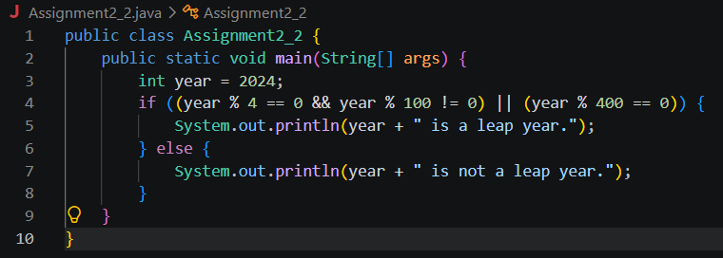

Problem 3: Days of the Week
C-DAC Mumbai

Problem Statement:
Write a Java program that takes an integer between 1 and 7 and prints the corresponding day of the week using a switch-case statement. If the input is outside the range of 1 to 7, the program should display "Invalid day number".

Predefined Value:
Day number = 3

Expected Output:
The day is Wednesday.

Code:
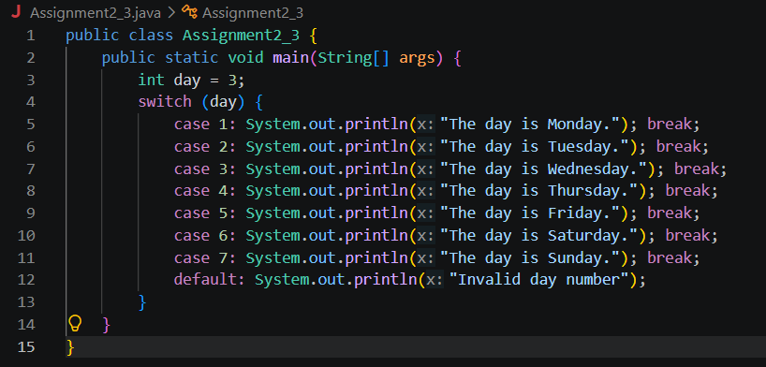

Problem 4: Identify the Values of Uninitialized Variables

Scenario:
You are working on a program that handles different data types. Your manager has asked you to quickly check the values of various variables, but you’re in a rush and forget to initialize them. As you go through the code, you expect some values to show up, but Java has something else in mind. Your task is to fix the issue and ensure the variables hold proper values.

Instructions:
- Declare the following variables:
byte a; short b; int c; long d; float e; double f; char g;
boolean h;

- Print out their values.

Code:
